
SOFTWARE CONSTRUCTION & DEVELOPMENT
LAB TASK 3

Submitted by :
Hira Iqbal– 131
(BSSE – 5C)

EXCERCISE 01:
A program may produce the correct result and still be difficult to extend or maintain. Consider the following
single-class implementation.
ResultDemo:
• What changes are required if the application must store 500 students?
• Where should grade rules be changed if the grading policy changes?
• Which part of the code could be reused by another application?
• Which data should be protected from uncontrolled modification?

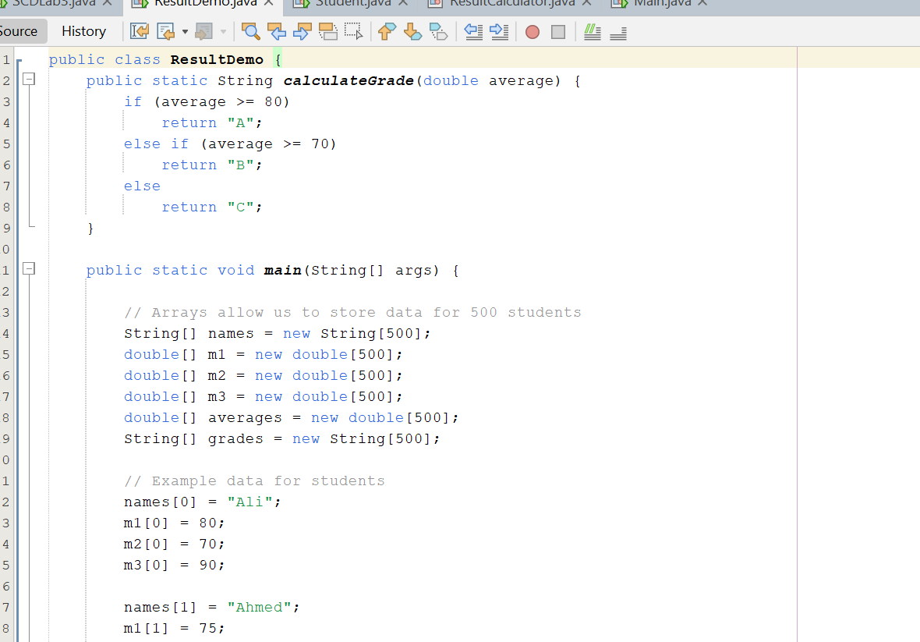
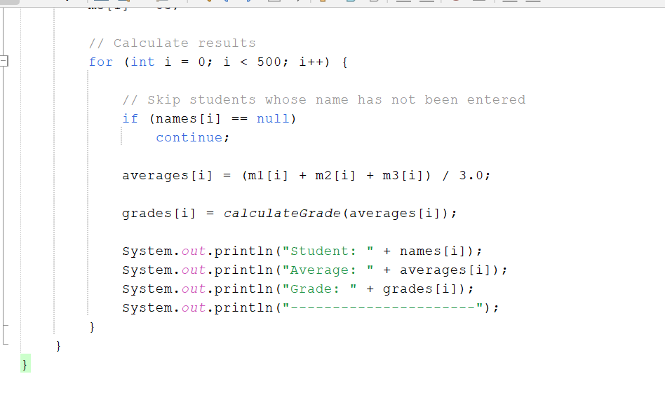

OUT PUT:
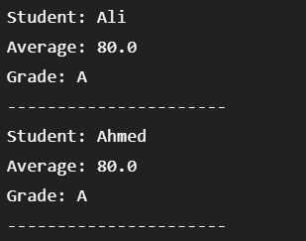

The fields are private. Other classes obtain the values through methods. This
introduces encapsulation and reduces direct dependency on the object&#39;s internal representation.
Class - Student:
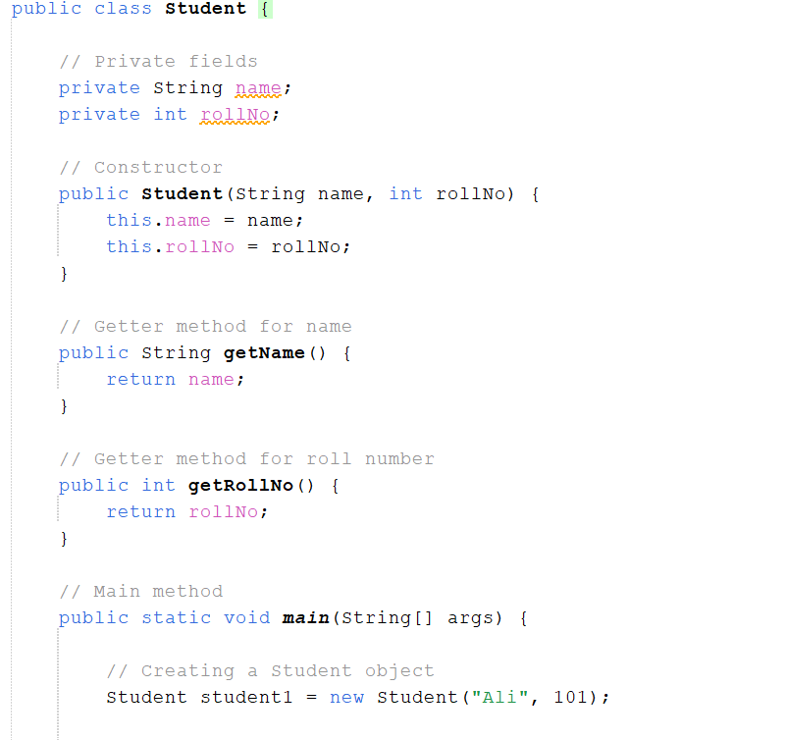

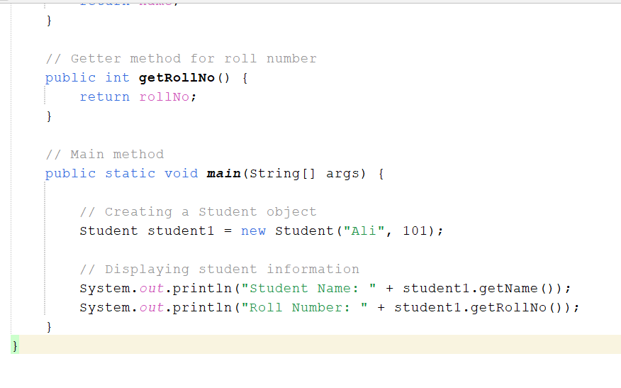
OUT PUT:
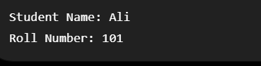
Class – ResultCalculator:
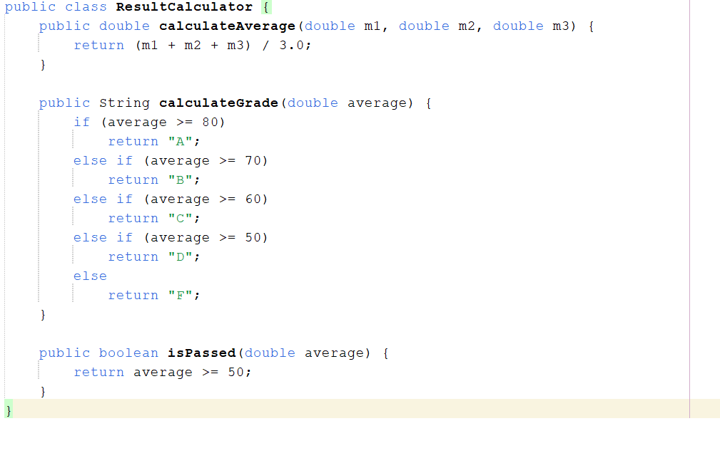

OUT PUT:
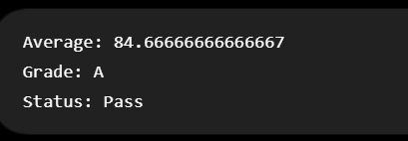

Class – Main:
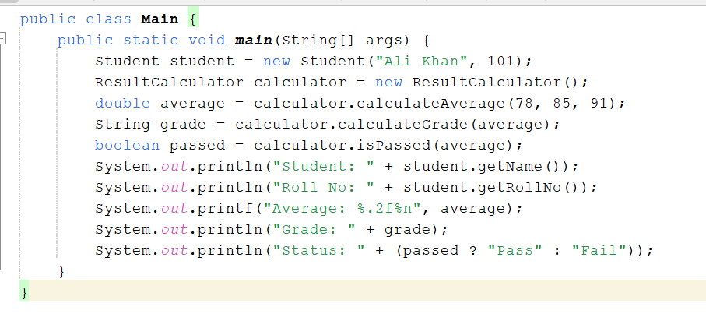
OUT PUT:
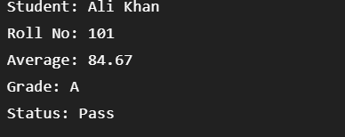
Calculation:
(78 + 85 + 91) / 3 = 84.666
Exercise 2 — Bank Account Construction
Required:
- accountNumber
- accountHolderName
- balance
- balance private
- deposit
- withdraw
- getBalance
- invalid deposits reject
- invalid withdrawals reject
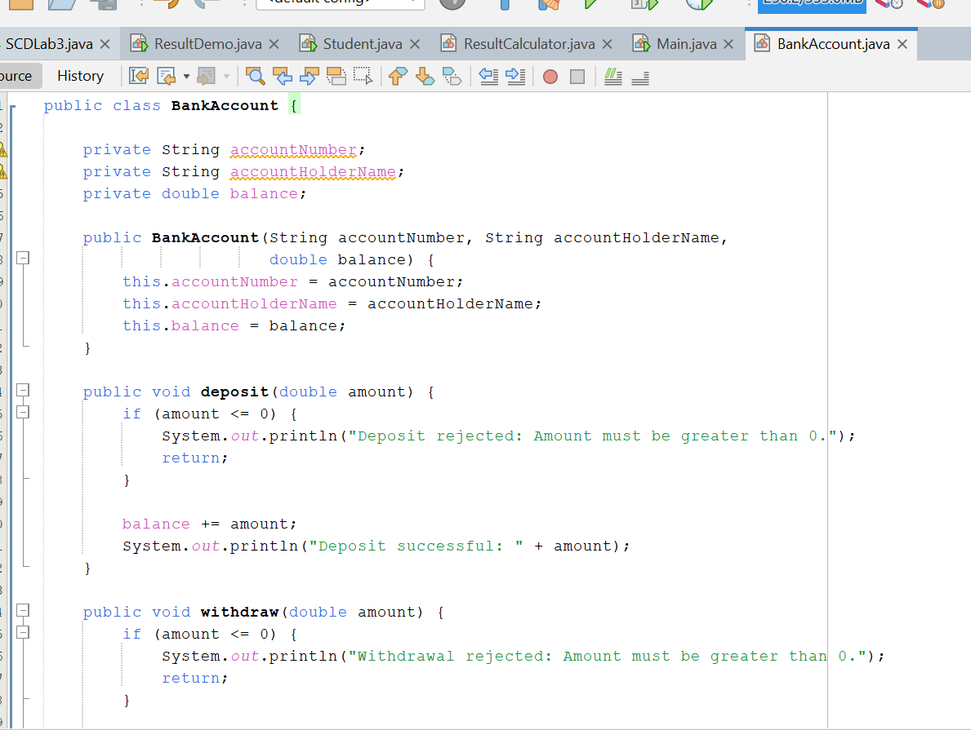
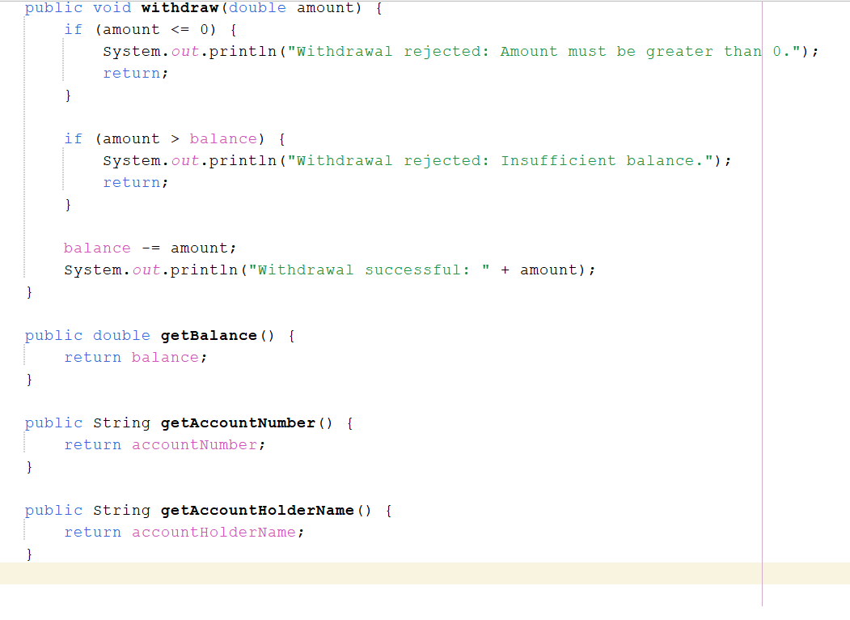

OUT PUT:
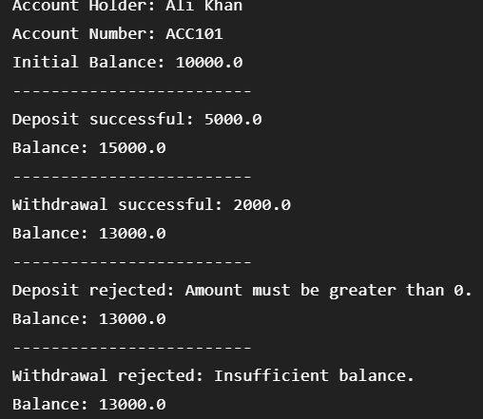

MAIN:
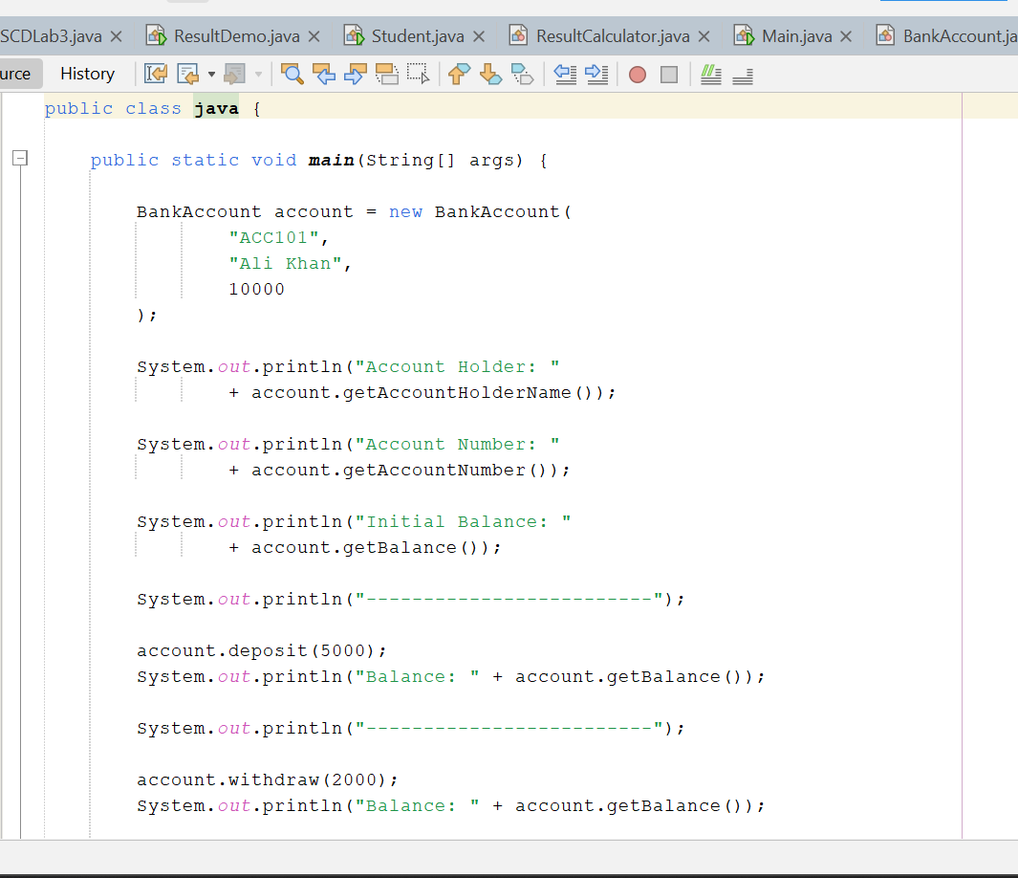
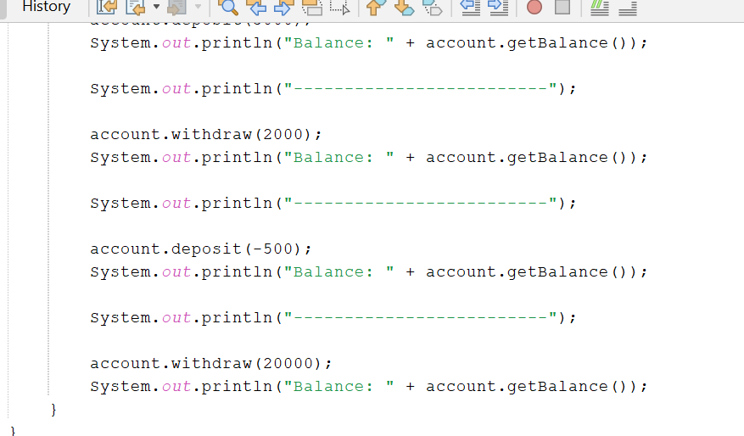

OUT PUT:
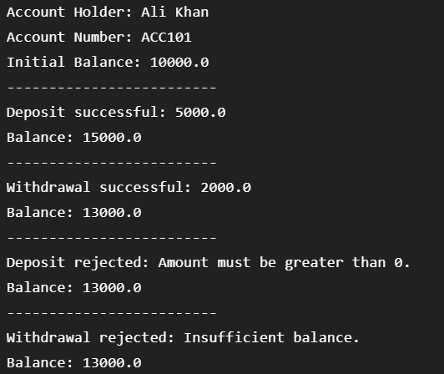

Exercise 3 — Refactor Poorly Structured Program
Yahan 3 classes banayenge:
- Product
- BillCalculator
- Main
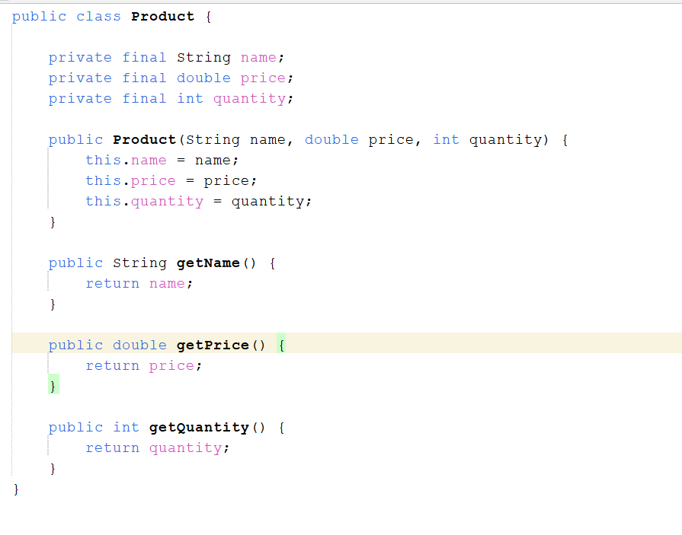
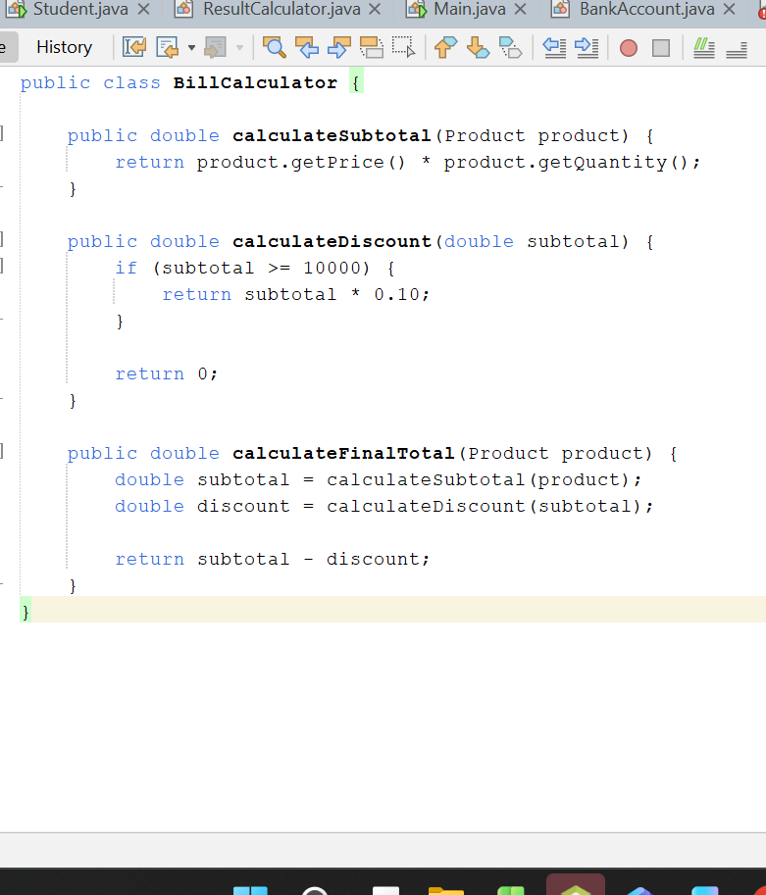

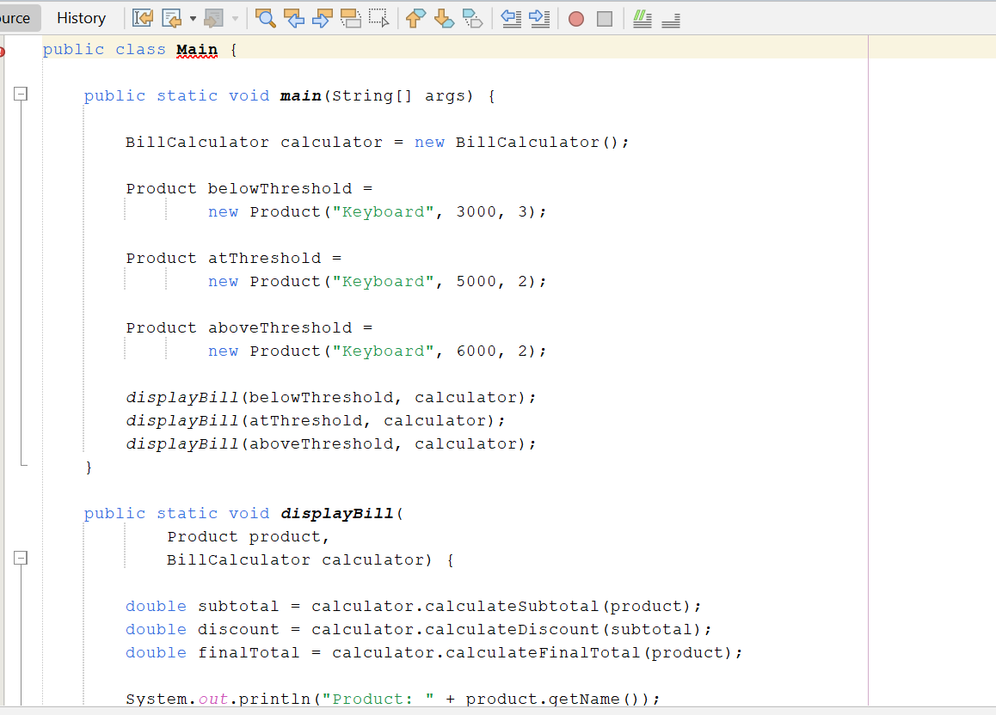
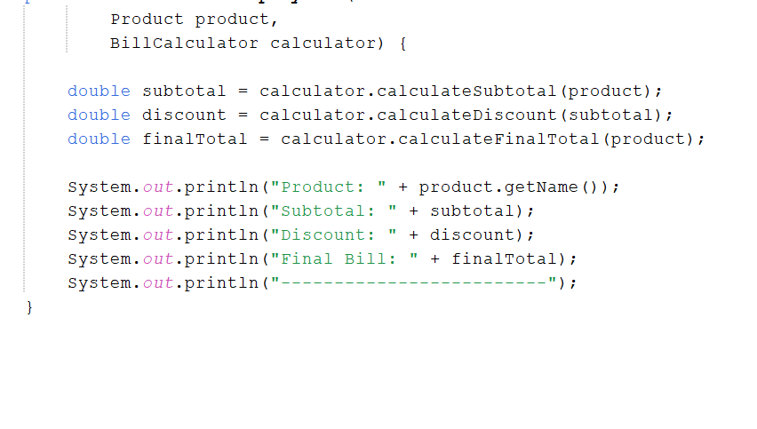
OUT PUT:
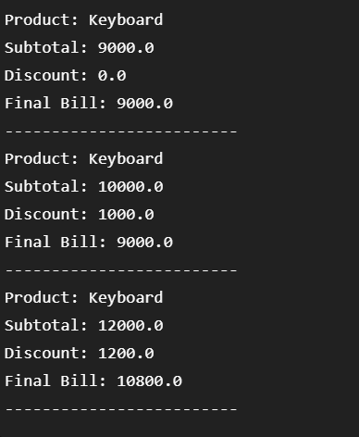

Exercise 4 — Class Result
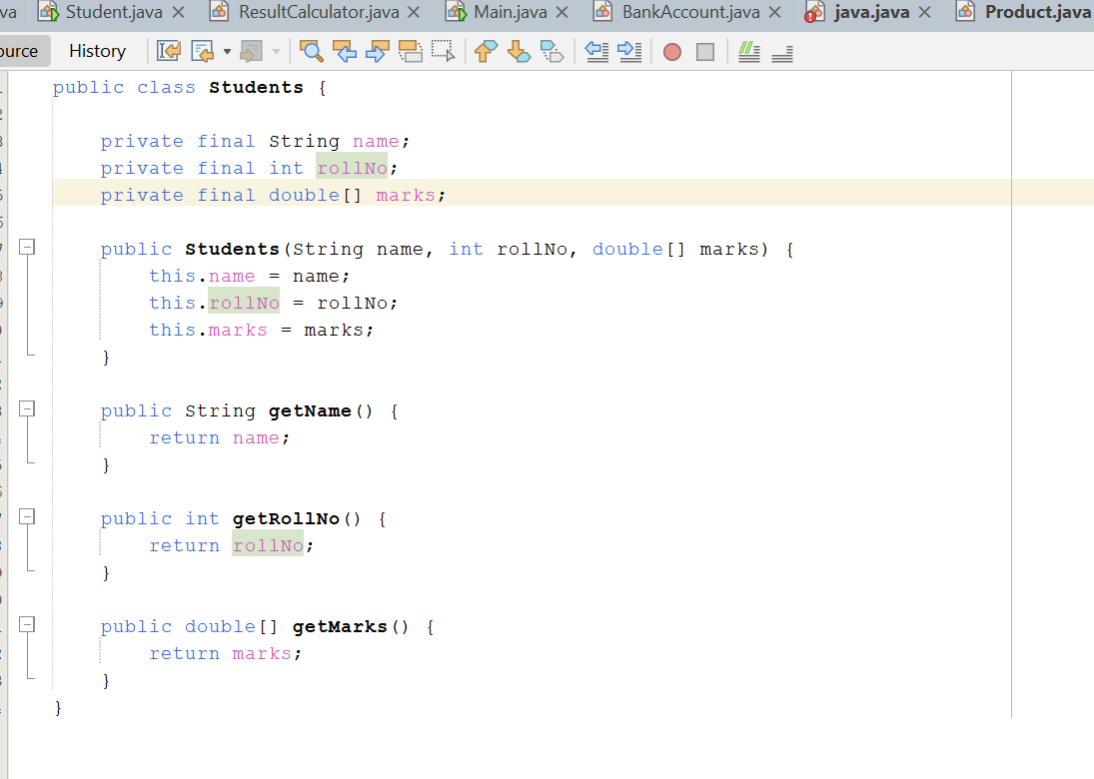

OUT PUT:
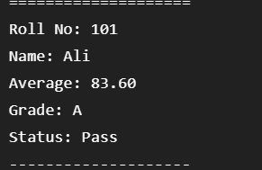
Exercise 5 — Construction Quality Challenge
Exercise 2 (Bank Account)
Requirements:
- No public data fields
- Methods short and meaningful
- No duplicated validation
- Meaningful names
- At least 5 test cases
- 2 boundary/invalid cases
- 2 design-intent comments

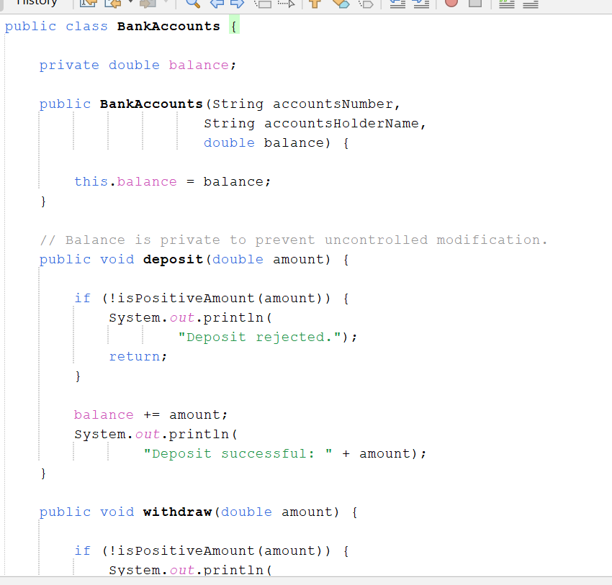

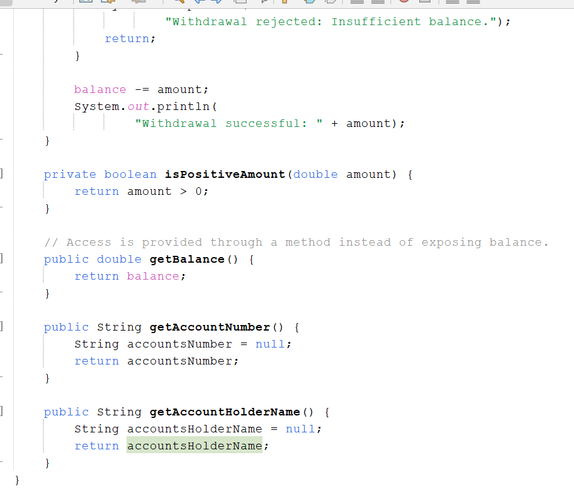
MAIN:
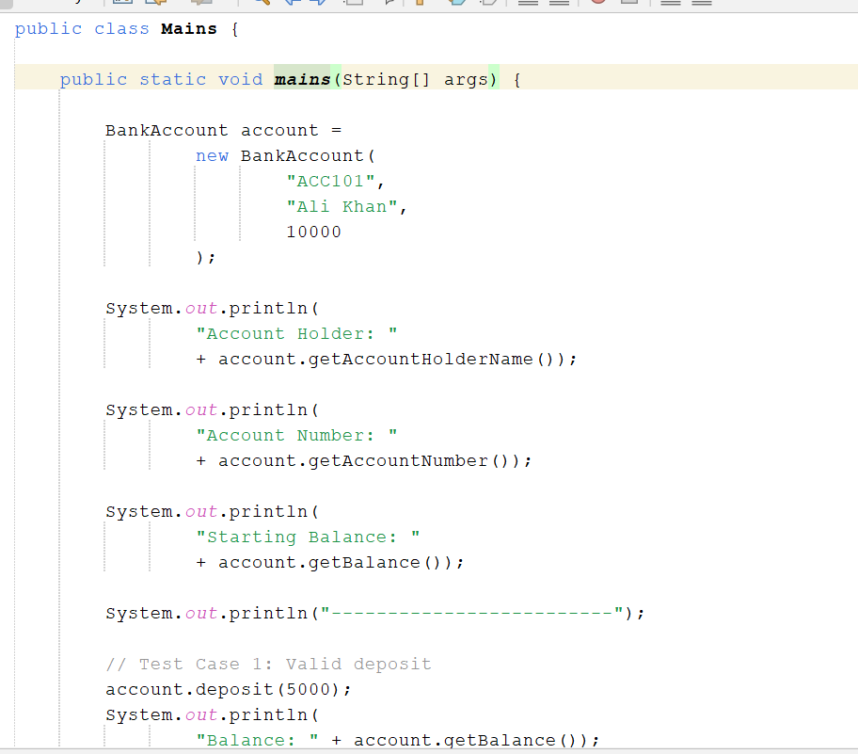

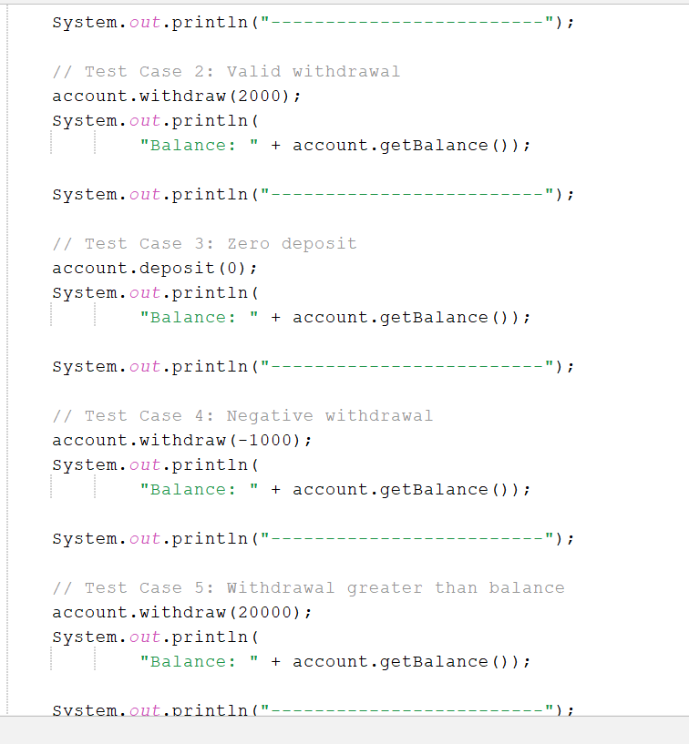
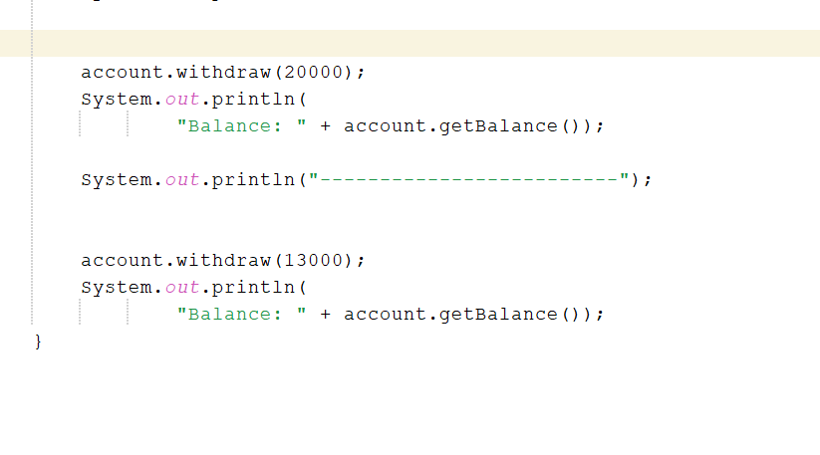
OUT PUT:
